The Bethlehem Star
“When they saw the star, they rejoiced exceedingly with great joy.” Matthew 2:10

October 2017

“If you abide in my word, you are truly my disciples, and you will know the truth, and the truth will set you free.”

John 8:31,32

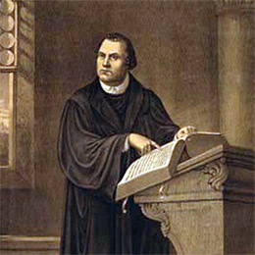
The Scripture Lessons for October:

Seventeenth Sunday after Pentecost
OT: Ezekiel 18:1-4, 25-32
Epistle: Philippians 2:1-4, 14-18
Gospel Matthew 21:23-27

Eighteenth Sunday after Pentecost
OT: Isaiah 5:1-7
Epistle: Philippians 3:4b-14
Gospel Matt. 21:33-46

Nineteenth Sunday after Pentecost
OT: Isaiah 25:6-9
Epistle: Philippians 4:4-13
Gospel Matt. 22:1-14

Twentieth Sunday after Pentecost
OT: Isaiah 45:1-7
Epistle: 1 Thessalonians 1:1-10
Gospel Matt. 22:14-22

Reformation Sunday
First Reading: Rev. 14:6,7
Epistle: Romans 3:19-28
Gospel John 8:31-36

500 Years and Counting

What was, and is, the Reformation about? The simple answer is Jesus and His Gospel. The years leading up to Martin Luther and the Reformation are known in church history as the dark ages. The clear meaning of the Gospel was hidden behind church dogma and popes who often contradicted each other. In Luther’s day the gospel was hidden behind a church practice known as indulgences. By purchasing indulgences the faithful could obtain the remission of temporal punishment resulting from sin for themselves and also for the souls in Purgatory. For the Roman Catholic Church the selling of indulgences was money making scheme. Roland Bainton in his famous biography on Luther called them the bingo of the sixteenth century. Luther became incensed over the practice of indulgences primarily because the gospel was not some kind of commodity that could be bought. The forgiveness of sins and the peace that comes from this gift comes from Christ alone free of charge.

Luther sought to change the Roman Catholic Church over this practice. Initially Luther believed the pope would change his mind after seeing what the Scriptures clearly taught about the forgiveness of sins. The pope refused to listen to Luther about the Gospel. Instead, the pope excommunicated him and had Luther brought before Emperor Charles the 5th at the Diet of Worms on April 18th 1521.

While at the Diet of Worms Luther gave his impassioned speech about standing on the Word of God. He said,
Unless I am convicted by Scripture and plain reason - I do not accept the authority of popes and councils, for they have contradicted each other - my conscience is captive to the Word of God. I cannot and I will not recant anything, for to go against conscience is neither right nor safe. Here I stand, I cannot do otherwise. God help me. Amen.

Continued on the next page……….

Bethlehem Evangelical Lutheran Church 202 W. Jefferson St. Morris, IL 60450
www.blcmorris.org Church office: 815-942-1145 Pastor Patrick Lohse 815-584-7122

October Birthdays and Anniversaries:

2 Dennis/Fran McCluckie
Kyleen Johnson
5 Joshua Lunde
David Hatz II
6 Allen Pilch
7 Lisa Nash
9 Josephine Greisen
11 Jaxon Borchers
13 Abigail Borchers

16 Mason Daggett
17 Gerald Nelson
Vance/Barb Vaksdal
18 Penny Hexdall
20 Sandra Timmons
Jim/Holly Skinner
22 Kyle Jacobson
Brad/Kristine Jacobson
Matt Lawton
23 Sue Gipes
24 Dennis McCluckie
27 John Enger
28 Peter Smyk

What we must take from Martin Luther’s life and his teachings is the centrality of God’s Word. It is only through God’s Word that we come to know about our sin, and it is God’s Word the delivers the word of promise of Christ that our sins have been washed away by the blood of Jesus. The Reformation was and is significant because it is a return to God’s Word! We celebrate the 500th anniversary of the Reformation not simply as a remembrance of God’s work through Luther, but the ongoing work of God in the lives of His children today as they stand upon His Word.

The motto of the Reformation is Verbum Domini Manet in Aeternum “The Word of the Lord Endures Forever.” This is the confident expression of the enduring power and authority of God’s Word. God’s Word was the source of Luther’s power to stand against those who sought to destroy him and the clear teaching of the Gospel. In some ways a lot has changed since Luther’s day and in other ways it has not. We know that Satan is still attacking the church and that there are those in our country who want to silence the Gospel. In the same vein as Luther let us take up God’s Word and say “Here I stand, I cannot do otherwise.”

Verbum Domini Manet in Aeternum!

Pastor Patrick Lohse

p.s. Come and hear more about Martin Luther and the Reformation on Saturday, October 28 at 5 pm in Fellowship Hall. Following a wonderful dinner will be a presentation on the Reformation by Pastor Steven Lombardo Sr.

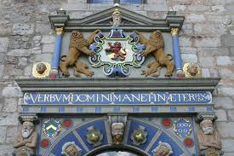

Bethlehem Evangelical Lutheran Church 202 W. Jefferson St. Morris, IL 60450
www.blcmorris.org Church office: 815-942-1145 Pastor Patrick Lohse 815-584-7122

If you would like to “ask the Pastor” a question you can write it down on piece of paper and hand it to me or email me at (lohs0016@umn.edu). Your name will not be printed with your question.

“Pastor, what is wrong with the world today and how can we fix it?”

The Bible helps us understand these two questions. We tend to focus on the evil “out there” in the world and forget about the darkness that is close to us. Colossians 1:19 says “And you, who once were alienated and hostile in mind, doing evil deeds.” All of us are born with a corrupt sinful nature. From this sinful nature flows all sorts of sins like anger, wrath, and murder. We all need to be saved from ourselves first and foremost. Unfortunately we think we can rehabilitate ourselves and society with enough education and government control.

The answer to our problem is only found in the work of Jesus Christ. Right after verse 19 Paul says “He (i.e. Jesus) has now reconciled in his body of flesh by death, in order to present you holy and blameless and above reproach before Him.” Jesus’ death on the cross has brought reconciliation. To reconcile means to restore a relationship. Through Jesus we are forgiven of all our sins and are declared holy and blameless. Faith in Christ changes our lives here on earth and for all eternity.

As the darkness continues to engulf our nation we have the opportunity to bring the light of Jesus to people so they can experience forgiveness and a new heart. Jesus is our only solution!
Bethlehem Evangelical Lutheran Church 202 W. Jefferson St. Morris, IL 60450
www.blcmorris.org Church office: 815-942-1145 Pastor Patrick Lohse 815-584-7122

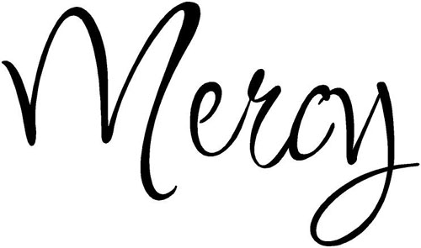
“Truly, I say to you, as you did it to one of the least of these my brothers, you did it to me.” Matthew 25:40

FFHM Orphanage Mission Project

Items needed for September/October are:

Jackets, hoodies, and leggings.
Crayola color) crayons, glue guns, glue
sticks, balloons, stickers, & backpacks

sticks, balloons, stickers, backparkers (Sharpie permanent; Crayola color) crayons, glue guns, glue sticks, balloons, stickers, backp Socks Underwear (boys & girls size 3-5)
There are collection boxes at both entrances. Thank you for your compassion.

Mark your calendar for the following Sunday School/Youth Group Activities in October:
- We are planning an outing to Heap’s Farm on October 22nd. Lunch will be provided following Sunday School in Fellowship Hall.

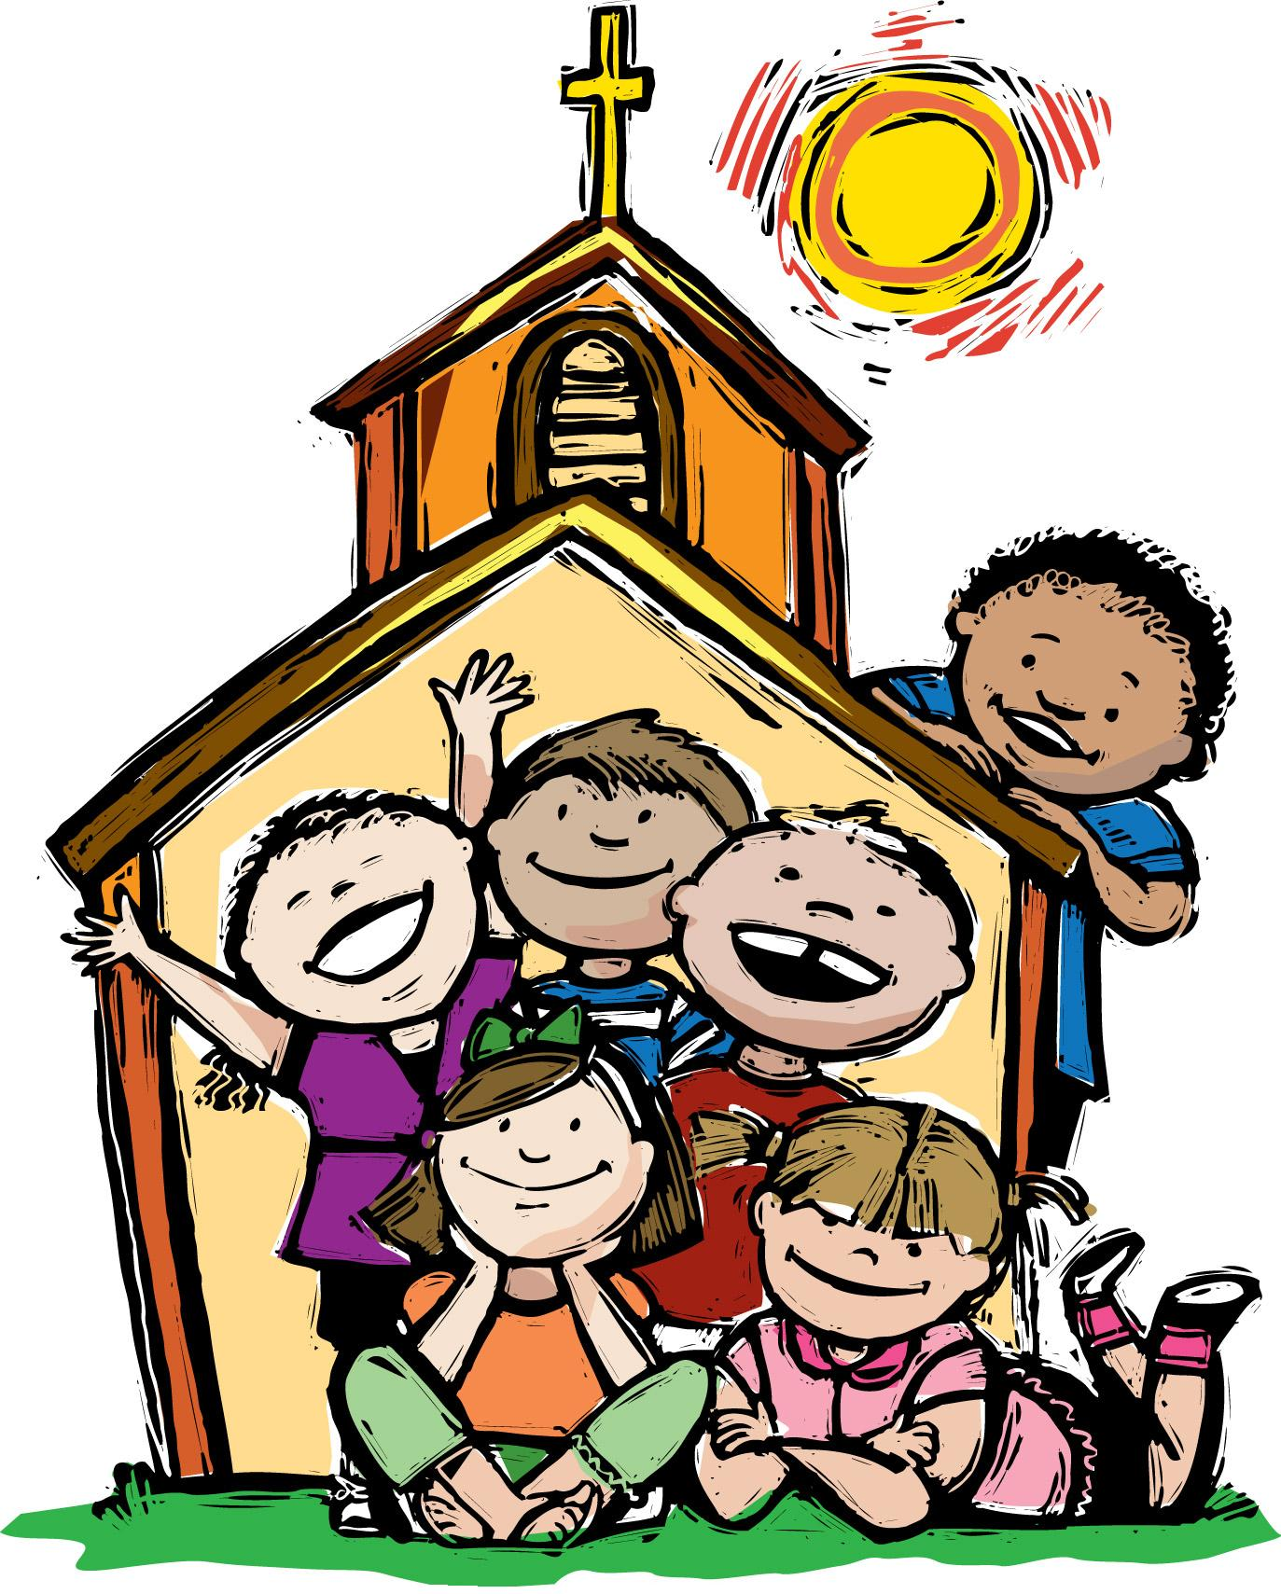

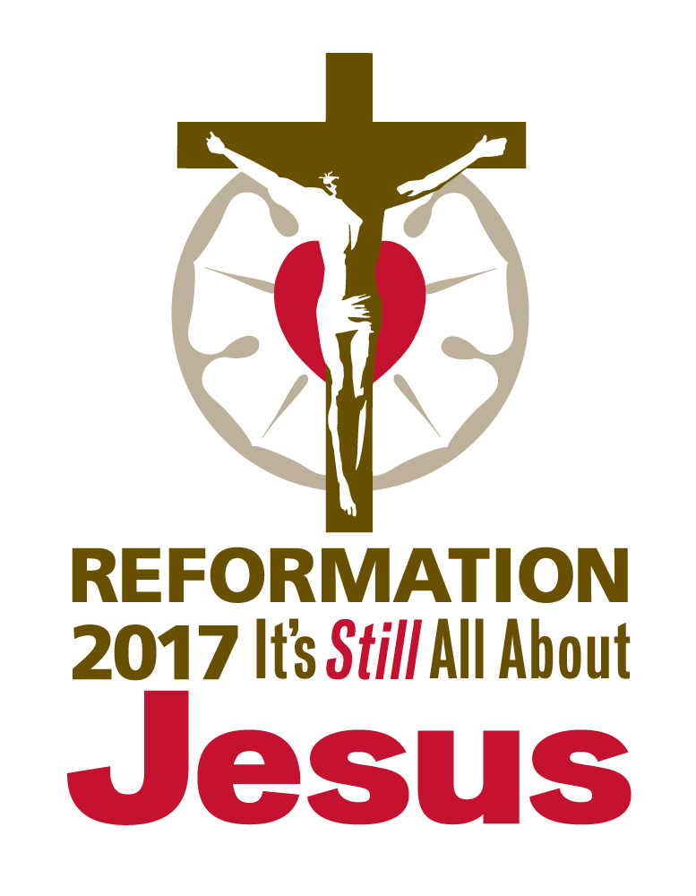

Holy Humor

“A time to laugh” Ecclesiastes 3:4

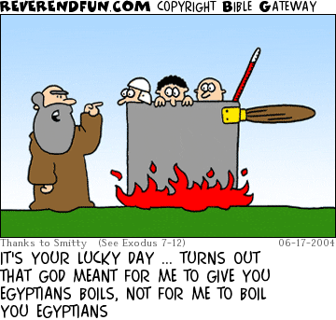

Other Reformation Heroes

Philip Melanchthon: He systematized Luther’s ideas and defended them in public. He is the author of the Augsburg Confession, which is the primary expression of the Lutheran faith.

Martin Chemnitz: He vigorously defended the Lutheran faith after Luther’s death. He is the author of the Formula of Concord.

Kathrine Von Bora: She was a former nun that learned from Luther that we are saved by God’s grace through faith. She married Luther and they had six children. Luther spoke of his dependence upon her by saying “Katie, my rib.”

Bethlehem Evangelical Lutheran Church 202 W. Jefferson St. Morris, IL 60450
www.blcmorris.org Church office: 815-942-1145 Pastor Patrick Lohse 815-584-7122

Financial Update for the Month of September

General Fund Missions
Needed to meet monthly budget: $16,613.00 $1108
Offerings Received: $12,427.00 $795
Net difference needed: $4,186.00 $313

Each one must give as he has decided in his heart, not reluctantly or under compulsion, for God loves a cheerful giver. 2 Corinthians 9:7

 | October 2017
Sun | Mon | Tue | Wed | Thu | Fri | Sat
1  Seventeenth Sunday after Pentecost  Worship 9 am  Sunday School 10:15 am | 2 | 3  Ladies Bible Study 9:30 am  Deacons Meeting 6:30 pm | 4  Sr. Choir Practice 6:30 pm | 5 | 6 | 7  Men’s Bible Study (Sherwood Oaks) 7:30 am
8  Eighteenth Sunday after Pentecost  Worship 9 am  Sunday School 10:15 am | 9 | 10  Ladies Bible Study 9:30 am  Bethlehem Women’s Fellowship 5:30 pm | 11  Confirmation: 4:30 -6:30 pm  Sr. Choir Practice 6:30 pm | 12 | 13  BLC Mom Squad 9:45-11:15 am | 14  Men’s Bible Study (kitchen): 7:30 am  Gospel of Mark
15  Nineteenth Sunday after Pentecost  Worship 9 am  Sunday School 10:15 am | 16 | 17  Ladies Bible Study 9:30 am | 18  Confirmation: 4:30 -6:30 pm  Sr. Choir Practice 6:30 pm | 19 | 20 | 21  Men’s Bible Study (kitchen): 7:30 am  Gospel of Mark
22  Twentieth Sunday after Pentecost  Worship 9 am  Sunday School 10:15 am | 23 | 24  Ladies Bible Study 9:30 am | 25  Confirmation: 4:30 -6:30 pm  Sr. Choir Practice 6:30 pm | 26 | 27  BLC Mom Squad 9:45-11:15 am | 28  Men’s Bible Study (kitchen): 7:30 am  Gospel of Mark  Reformation Banquet 5 pm
29  Reformation Sunday  Worship 9 am  Sunday School 10:15 am | 30 | 31  Ladies Bible Study 9:30 am | Make plans to attend our Church’s 500th Anniversary of the Reformation banquet on Saturday, October 28th at 5 pm. Pastor Steven Lombardo Sr. will be our keynote speaker.

