The Bethlehem Star
“When they saw the star, they rejoiced exceedingly with great joy.” Matthew 2:10

December 2017

“For to us a child is born, to us a son is given; and the government shall be upon his shoulder, and his name shall be called Wonderful Counselor, Mighty God, Everlasting Father, Prince of Peace.” Isaiah 9:6

2 Timothy 3:2

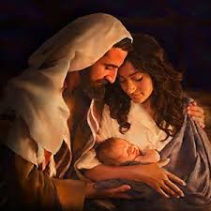
The Scripture Lessons for December:

First Sunday of Advent
OT: Isaiah 64:1-9
Epistle: 1 Cor. 1:3-9
Gospel Mark 11:1-10

Second Sunday of Advent
OT: Isaiah 40:1-11
Epistle: 2 Peter 3:8-14
Gospel Mark 1:1-8

Third Sunday of Advent
OT: Isaiah 61:1-4, 8-11
Epistle: 1 Thess: 5:16-24
Gospel John 1:6-8, 19-28
Fourth Sunday of Advent
OT: 2 Samuel 7:1-11, 16
Epistle: Romans 16:25-27
Gospel Luke 1:26-38

First Sunday of Christmas
OT: Isaiah 61:10-62:3
Epistle: Gal. 4:4-7
Gospel Luke 2:22-40

The “so what?” of Jesus’ birth

Have you ever thought about the implications of Jesus’ birth? The incarnation, God becoming flesh and subjecting Himself to His creation, really does have profound effects on every single human being. Let’s set aside some time and ponder the deep significance of Jesus’ birth.

The first thing we should take note of is that Jesus’ birth reveals to us the truth that God dwells with man. The Old Testament prophecy spoken 700 years before Jesus’ birth says: “Behold, the virgin shall conceive and bear a son, and shall call his name Immanuel.” (Isaiah 7:14). When the angel spoke to Joseph about the fulfillment of that verse in Jesus, he said that name Immanuel means “God with us” (Matthew 1:23). Our God does not remain distant from His people, but is willing to enter a relationship with them through Jesus Christ.

Another reason why Jesus’ birth is significant is because His birth means sins can be forgiven. Once again, the angel told Joseph that he was to name the child in Mary’s womb Jesus because “he will save his people from their sins.” (Matthew 1:21). The name, Jesus, literally means “God saves.” Dear friend, God can forgive you of all your sins, He will forgive you! That forgiveness is found in the one born for you, Jesus Christ.

Ponder this blessed truth, the birth of Jesus gives everlasting peace. At the birth of Jesus the angel and the heavenly chorus joined in praising God by saying, “Glory to God in the highest, and on earth peace among those with whom he is pleased!” (Luke 2:14). The peace that is spoken of here in Luke’s Gospel is the peace that results as Jesus satisfies the wrath of God regarding our sin. This is why we sing in “Hark! The Herald Angels Sing” the line “Peace on earth, and mercy mild, God and sinners reconciled.”

Continued on the next page………………..

Continued on the next page……….

Bethlehem Evangelical Lutheran Church 202 W. Jefferson St. Morris, IL 60450
www.blcmorris.org Church office: 815-942-1145 Pastor Patrick Lohse 815-584-7122

December Birthdays and Anniversaries:

2 Anita Sampson
3 Lynn Ogden
4 Caroline Wallin
5 Shirley Lambros
13 Esther Reinbacher
Beth Dunn
16 Allison Skinner
17 Rick Stump
18 Anna Lunde
21 Jocelyn Narwick
Jack Enger
22 Fran McCluckie
H. James Narwick
24 Caroll Hausken
29 Brian Wildenhain
31 Betty Nelson
Sheree Narwick

I don’t know about you, but I sure am glad that on account of Jesus, God is no longer angry over my sins and will punish me for them.

Related to this peace that we now have with God through faith in Jesus, is joy. The angels announced to the shepherds on the night of Jesus birth: “Fear not, for behold, I bring you good news of great joy that will be for all the people.” (Luke 2:10). I love that phrase “good news of great joy.” At the birth of all of my three sons, I couldn’t wait to tell the news of their births. Births are always exciting. New life that God creates is always praise worthy. The birth of Jesus is off the charts in terms of excitement. Because of His birth I can have life for ever and ever! Because of Jesus, I can have joy even in the face of evil, hardship, and death. Christmas means no body can rob me of the joy of my Lord, who promises to always be with me, love me and care for me.

The implications of Christmas are so many. The significance of Jesus’ birth means everything. In the midst of the hustle and bustle that goes with this season may we all take time out of our busy schedules and ponder in our hearts what the birth of Jesus means for us today.

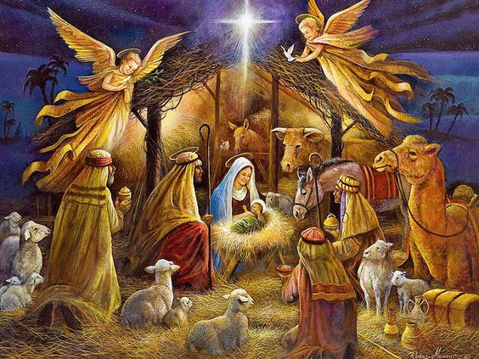

From my family to yours, Merry Christmas!
-The Lohse’s

Bethlehem Evangelical Lutheran Church 202 W. Jefferson St. Morris, IL 60450
www.blcmorris.org Church office: 815-942-1145 Pastor Patrick Lohse 815-584-7122

If you would like to “ask the Pastor” a question you can write it down on piece of paper and hand it to me or email me at (lohs0016@umn.edu). Your name will not be printed with your question.

“Pastor, I know that many of our Christian hymns have interesting back stories to them. Are there any fascinating stories behind our Christmas carols?”

You are right in that many of our Christian hymns have interesting stories behind them. Some are born out of great distress and spiritual battles, others due to hymn-writers experiencing God’s grace in profound ways. James Montgomery author of the hymn, “Angels, From the Realms of Glory” is no exception.

James Montgomery grew up in England in the late 18th century. His parents were missionaries to the West Indies. While he was in seminary in England his parents died on the mission field. Their unexpected death shook him to the core. He dropped out of seminary and for a period lived a life of aimless discouragement.

His life took a positive turn when he became interested in newspaper work and writing. At the age of 23 he became the editor of the Sheffield Register in London, a position he would hold for 31 years.

Montgomery wrote “Angels, From the Realms of Glory” originally as a poem for his newspaper on December 24th, 1816. Later it was published in a hymnal entitled “Montgomery’s Original Hymns” and the song was known as “Good Tidings of Great Joy to All People.” All in all, Montgomery wrote approximately 400 hymns. After retiring from the newspaper business, he devoted his life to the promotion of foreign missions.

Bethlehem Evangelical Lutheran Church 202 W. Jefferson St. Morris, IL 60450
www.blcmorris.org Church office: 815-942-1145 Pastor Patrick Lohse 815-584-7122

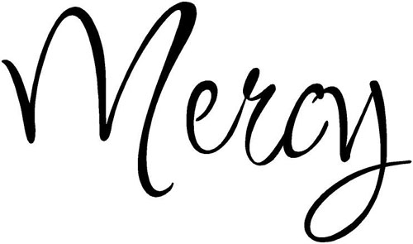
“Truly, I say to you, as you did it to one of the least of these my brothers, you did it to me.” Matthew 25:40

FFHM Orphanage Mission Project

Items needed for November/December are:

Kids’ running shoes (sizes 5-9)
Crayola color) crayons, glue guns, glue
sticks, balloons, stickers, & backpack sticks, balloons, stickers, backparkers (Sharpie permanent; Crayola color) crayons, glue guns, glue sticks, balloons, stickers, backp Socks Underwear (boys & girls size 3-5)
There is a collection box at in the fireside room.

Mark your calendar for the following Sunday School/Youth Group Activities in December:
- The Sunday School Christmas program will be on Sunday, December 17th at 10:30 am. The kids have been working real hard on this program to honor our Lord’s birth. Come and enjoy the program and songs.

Holy Humor

“A time to laugh” Ecclesiastes 3:4

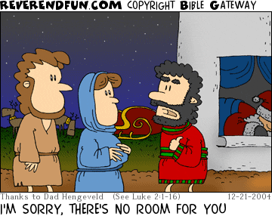

Here is some Christmas Bible trivia:

- Who told Mary and Joseph to go to Bethlehem?

- Which Old Testament Prophet had the most to say about the birth of Christ?

- What are the meanings of the names Jesus and Immanuel?

- What did the angels sing to the Shepherds?

Answers:
Read Luke 2:1; Isaiah; Matthew 1:21,23; Luke 2:14

Bethlehem Evangelical Lutheran Church 202 W. Jefferson St. Morris, IL 60450
www.blcmorris.org Church office: 815-942-1145 Pastor Patrick Lohse 815-584-7122

Financial Update for the Month of November

General Fund Missions
Needed to meet monthly budget: $16,613.00 $1108
Offerings Received: $23,744.00 $790
Net difference needed: $ $318

Each one must give as he has decided in his heart, not reluctantly or under compulsion, for God loves a cheerful giver. 2 Corinthians 9:7

 | December 2017
Sun | Mon | Tue | Wed | Thu | Fri | Sat
 |  |  |  |  | 1 | 2  Men’s Bible Study (Sherwood Oaks) 7:30 am
3  First Sunday of Advent  Worship 9 am  Sunday School 10:15 am | 4 | 5  Ladies Bible Study 9:30 am  Deacons Meeting 6:30 pm | 6  Jr. Confirmation 4:30 pm  Sr. Confirmation  5:30 pm  Choir 6:30 pm | 7 | 8  BLC Mom Squad 9:45-11:15 am | 9  Men’s Bible Study (kitchen): 7:30 am  Gospel of Mark
10  Second Sunday of Advent  Worship 9 am  Sunday School 10:15 am | 11 | 12  Ladies Bible Study 9:30 am  Bethlehem Women’s Fellowship 5:30 pm | 13  Jr. Confirmation 4:30 pm  Sr. Confirmation  5:30 pm  Choir 6:30 pm | 14  Council Meeting 6:30 pm | 15 | 16  Men’s Bible Study (kitchen): 7:30 am  Gospel of Mark
17  Third Sunday of Advent  Worship 9 am (Cantata)  Sunday School Christmas program 10:30am | 18 | 19  Ladies Bible Study 9:30 am | 20  Jr. Confirmation 4:30 pm  Sr. Confirmation  5:30 pm | 21 | 22 | 23  Men’s Bible Study (kitchen): 7:30 am  Gospel of Mark
24  Fourth Sunday of Advent  Worship 9 am  Nativity of our Lord: Christmas Eve  Worship 5:00 pm | 25  Merry Christmas! | 26 | 27 | 28 | 29 | 30  Men’s Bible Study (kitchen): 7:30 am  Gospel of Mark
31  First Sunday of Christmas  Worship 9 am | Notes: Invite your friends and family to our Church’s Cantata, “The Gift Goes On.” Then stick around for our children’s Sunday School Christmas program at 10:30 am. There will be snacks and refreshments to follow.

